1. **Write a query to display the name (first name, last_name) and salary for all employees whose**

**salary is not in the range $10,000 through $15,000 and are in department 30 or 100.**

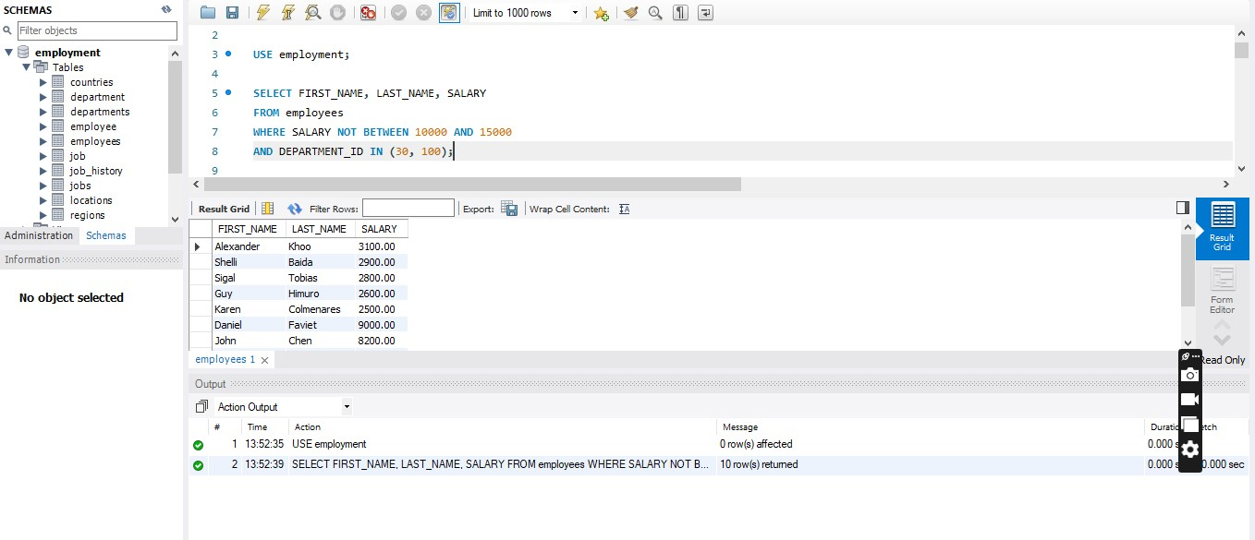

|  |  |  |
| --- | --- | --- |
| FIRST_NAME | LAST_NAME | SALARY |
| Alexander | Khoo | 3100 |
| Shelli | Baida | 2900 |
| Sigal | Tobias | 2800 |
| Guy | Himuro | 2600 |
| Karen | Colmenares | 2500 |
| Daniel | Faviet | 9000 |
| John | Chen | 8200 |
| Ismael | Sciarra | 7700 |
| Jose Manuel | Urman | 7800 |
| Luis | Popp | 6900 |

1. **Write a query to display the name (first_name, last_name) and hire date for all employees who were hired in 1987.**

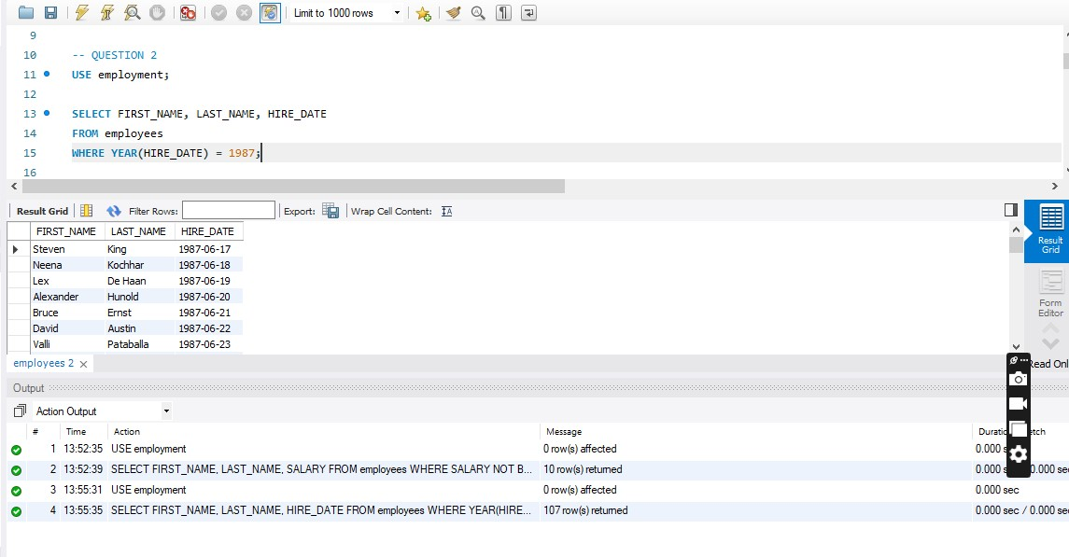

|  |  |  |
| --- | --- | --- |
| **FIRST_NAME** | **LAST_NAME** | **HIRE_DATE** |
| Steven | King | 6/17/1987 |
| Neena | Kochhar | 6/18/1987 |
| Lex | De Haan | 6/19/1987 |
| Alexander | Hunold | 6/20/1987 |
| Bruce | Ernst | 6/21/1987 |
| David | Austin | 6/22/1987 |
| Valli | Pataballa | 6/23/1987 |
| Diana | Lorentz | 6/24/1987 |
| Nancy | Greenberg | 6/25/1987 |
| Daniel | Faviet | 6/26/1987 |
| John | Chen | 6/27/1987 |
| Ismael | Sciarra | 6/28/1987 |
| Jose Manuel | Urman | 6/29/1987 |
| Luis | Popp | 6/30/1987 |
| Den | Raphaely | 7/1/1987 |
| Alexander | Khoo | 7/2/1987 |
| Shelli | Baida | 7/3/1987 |
| Sigal | Tobias | 7/4/1987 |
| Guy | Himuro | 7/5/1987 |
| Karen | Colmenares | 7/6/1987 |
| Matthew | Weiss | 7/7/1987 |
| Adam | Fripp | 7/8/1987 |
| Payam | Kaufling | 7/9/1987 |
| Shanta | Vollman | 7/10/1987 |
| Kevin | Mourgos | 7/11/1987 |
| Julia | Nayer | 7/12/1987 |
| Irene | Mikkilineni | 7/13/1987 |
| James | Landry | 7/14/1987 |
| Steven | Markle | 7/15/1987 |
| Laura | Bissot | 7/16/1987 |
| Mozhe | Atkinson | 7/17/1987 |
| James | Marlow | 7/18/1987 |
| TJ | Olson | 7/19/1987 |
| Jason | Mallin | 7/20/1987 |
| Michael | Rogers | 7/21/1987 |
| Ki | Gee | 7/22/1987 |
| Hazel | Philtanker | 7/23/1987 |
| Renske | Ladwig | 7/24/1987 |
| Stephen | Stiles | 7/25/1987 |
| John | Seo | 7/26/1987 |
| Joshua | Patel | 7/27/1987 |
| Trenna | Rajs | 7/28/1987 |
| Curtis | Davies | 7/29/1987 |
| Randall | Matos | 7/30/1987 |
| Peter | Vargas | 7/31/1987 |
| John | Russell | 8/1/1987 |
| Karen | Partners | 8/2/1987 |
| Alberto | Errazuriz | 8/3/1987 |
| Gerald | Cambrault | 8/4/1987 |
| Eleni | Zlotkey | 8/5/1987 |
| Peter | Tucker | 8/6/1987 |
| David | Bernstein | 8/7/1987 |
| Peter | Hall | 8/8/1987 |
| Christopher | Olsen | 8/9/1987 |
| Nanette | Cambrault | 8/10/1987 |
| Oliver | Tuvault | 8/11/1987 |
| Janette | King | 8/12/1987 |
| Patrick | Sully | 8/13/1987 |
| Allan | McEwen | 8/14/1987 |
| Lindsey | Smith | 8/15/1987 |
| Louise | Doran | 8/16/1987 |
| Sarath | Sewall | 8/17/1987 |
| Clara | Vishney | 8/18/1987 |
| Danielle | Greene | 8/19/1987 |
| Mattea | Marvins | 8/20/1987 |
| David | Lee | 8/21/1987 |
| Sundar | Ande | 8/22/1987 |
| Amit | Banda | 8/23/1987 |
| Lisa | Ozer | 8/24/1987 |
| Harrison | Bloom | 8/25/1987 |
| Tayler | Fox | 8/26/1987 |
| William | Smith | 8/27/1987 |
| Elizabeth | Bates | 8/28/1987 |
| Sundita | Kumar | 8/29/1987 |
| Ellen | Abel | 8/30/1987 |
| Alyssa | Hutton | 8/31/1987 |
| Jonathon | Taylor | 9/1/1987 |
| Jack | Livingston | 9/2/1987 |
| Kimberely | Grant | 9/3/1987 |
| Charles | Johnson | 9/4/1987 |
| Winston | Taylor | 9/5/1987 |
| Jean | Fleaur | 9/6/1987 |
| Martha | Sullivan | 9/7/1987 |
| Girard | Geoni | 9/8/1987 |
| Nandita | Sarchand | 9/9/1987 |
| Alexis | Bull | 9/10/1987 |
| Julia | Dellinger | 9/11/1987 |
| Anthony | Cabrio | 9/12/1987 |
| Kelly | Chung | 9/13/1987 |
| Jennifer | Dilly | 9/14/1987 |
| Timothy | Gates | 9/15/1987 |
| Randall | Perkins | 9/16/1987 |
| Sarah | Bell | 9/17/1987 |
| Britney | Everett | 9/18/1987 |
| Samuel | McCain | 9/19/1987 |
| Vance | Jones | 9/20/1987 |
| Alana | Walsh | 9/21/1987 |
| Kevin | Feeney | 9/22/1987 |
| Donald | OConnell | 9/23/1987 |
| Douglas | Grant | 9/24/1987 |
| Jennifer | Whalen | 9/25/1987 |
| Michael | Hartstein | 9/26/1987 |
| Pat | Fay | 9/27/1987 |
| Susan | Mavris | 9/28/1987 |
| Hermann | Baer | 9/29/1987 |
| Shelley | Higgins | 9/30/1987 |
| William | Gietz | 10/1/1987 |

1. **Create a view to count the number of employees, compute the average and the total salary**

**ordered in descending.**

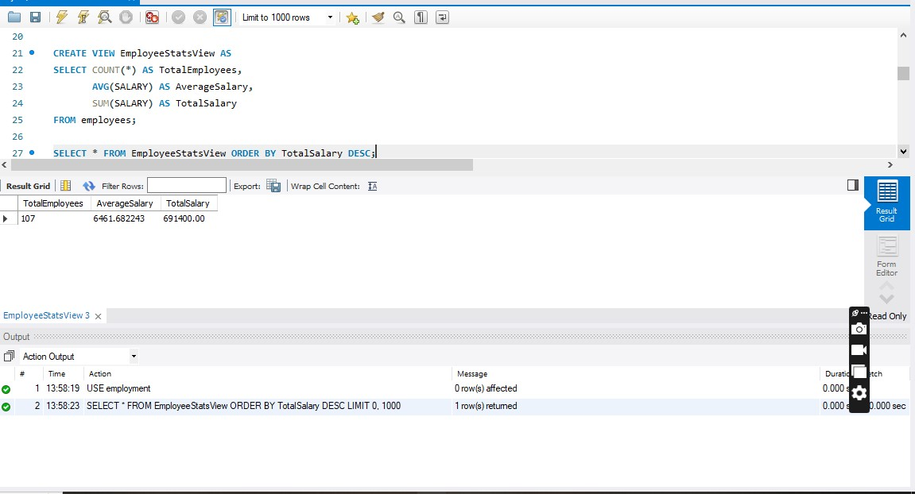

|  |  |  |
| --- | --- | --- |
| Total Employees | Average Salary | Total Salary |
| 107 | 6461.682243 | 691400 |
|  |  |  |

1. **Write a query to display the last name, job, and salary for all employees whose job is that of a**

**Programmer or a Shipping Clerk, and whose salary is not equal to $4,500, $10,000, or**

**$15,000.**

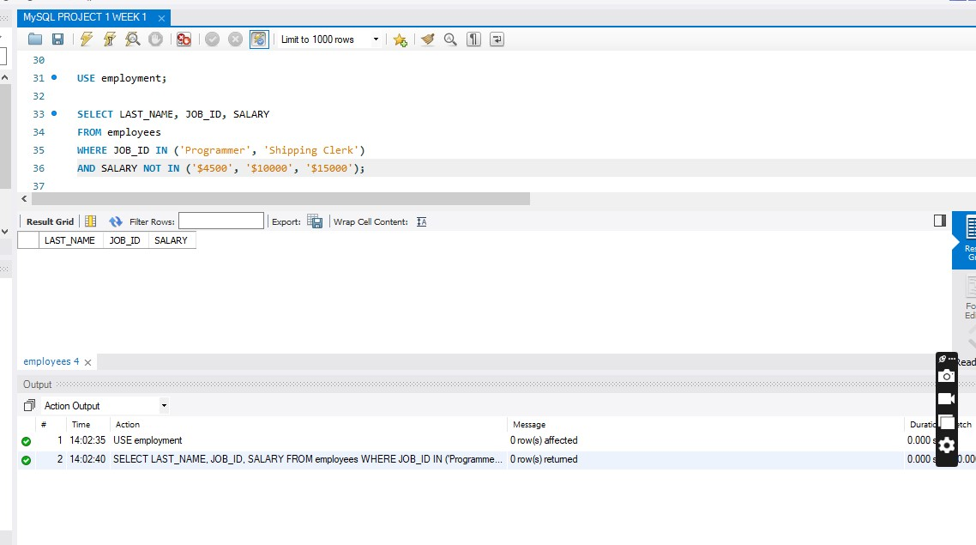

The table is empty showing none of the data falls under the Query

1. **Write a query to select all record from employees where last name in 'BLAKE', '**

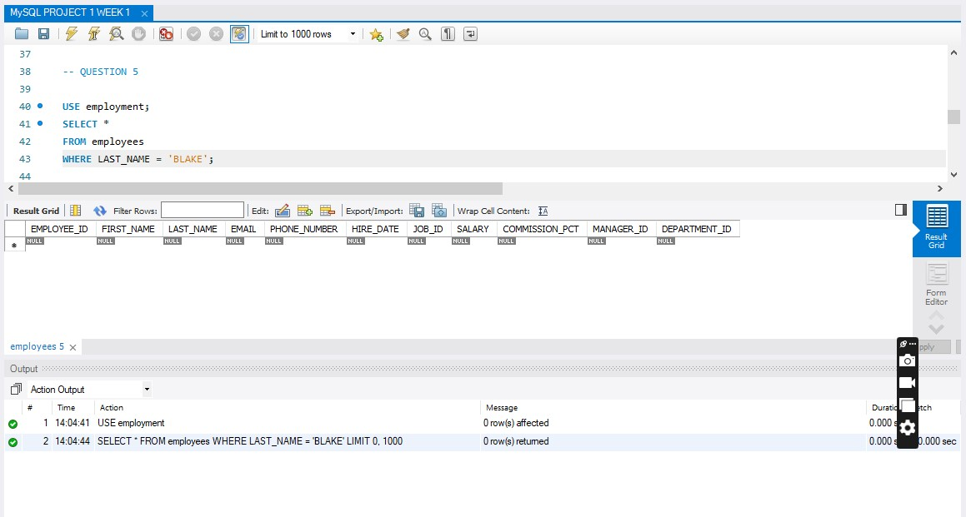

The table is empty showing none of the data falls under the Query

1. **PETER', 'KING' and 'FORD'.**

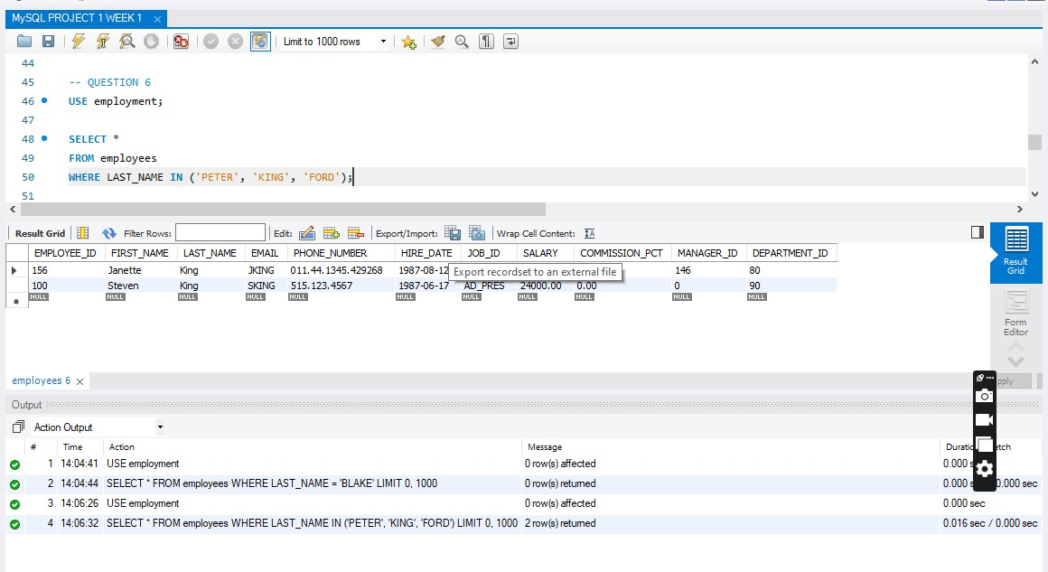

|  |  |  |  |  |  |  |  |  |  |  |
| --- | --- | --- | --- | --- | --- | --- | --- | --- | --- | --- |
| EMPLOYEE_ID | FIRST_NAME | LAST_NAME | EMAIL | PHONE_NUMBER | HIRE_DATE | JOB_ID | SALARY | COMMISSION_PCT | MANAGER_ID | DEPARTMENT_ID |
| 156 | Janette | King | JKING | 011.44.1345.429268 | 8/12/1987 | SA_REP | 10000 | 0.35 | 146 | 80 |
| 100 | Steven | King | SKING | 515.123.4567 | 6/17/1987 | AD_PRES | 24000 | 0 | 0 | 90 |

1. **Write a query to get the number of employees with the same job.**

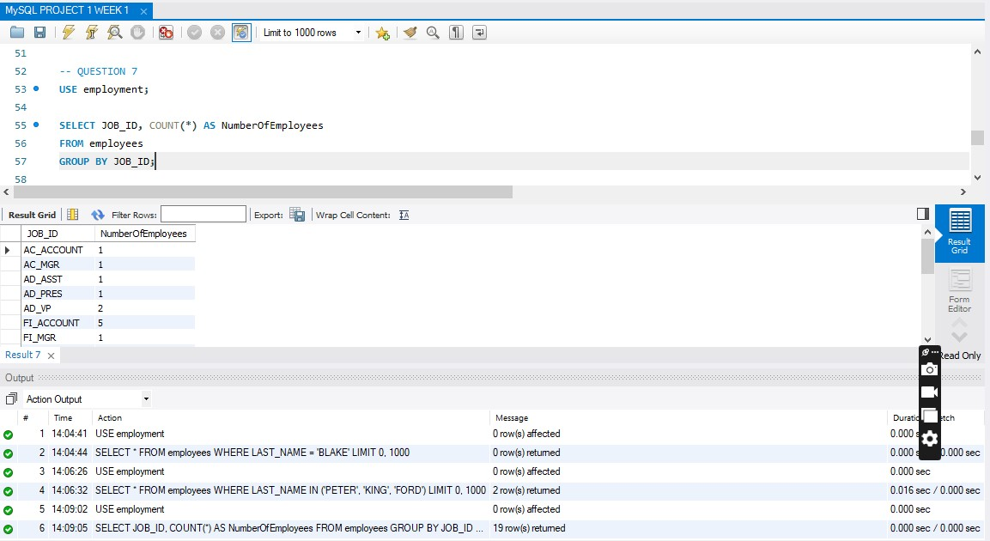

|  |  |
| --- | --- |
| JOB_ID | NumberOfEmployees |
| AC_ACCOUNT | 1 |
| AC_MGR | 1 |
| AD_ASST | 1 |
| AD_PRES | 1 |
| AD_VP | 2 |
| FI_ACCOUNT | 5 |
| FI_MGR | 1 |
| HR_REP | 1 |
| IT_PROG | 5 |
| MK_MAN | 1 |
| MK_REP | 1 |
| PR_REP | 1 |
| PU_CLERK | 5 |
| PU_MAN | 1 |
| SA_MAN | 5 |
| SA_REP | 30 |
| SH_CLERK | 20 |
| ST_CLERK | 20 |
| ST_MAN | 5 |
|  |  |

1. **Write a query to get the difference between the highest and lowest salaries**

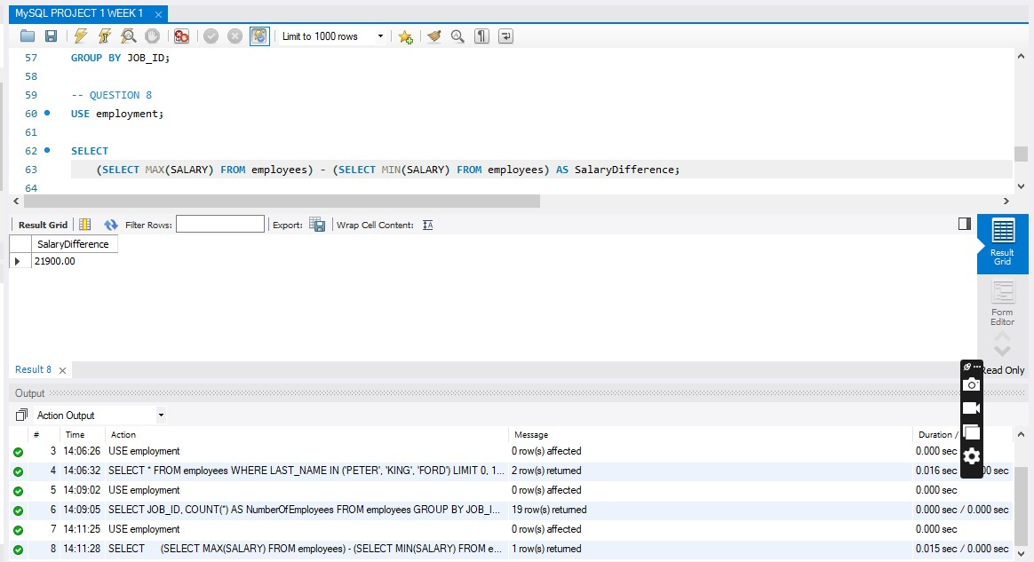

|  |
| --- |
| Salary Difference |
| 21900 |

1. **Create an ER Diagram and describe it.**

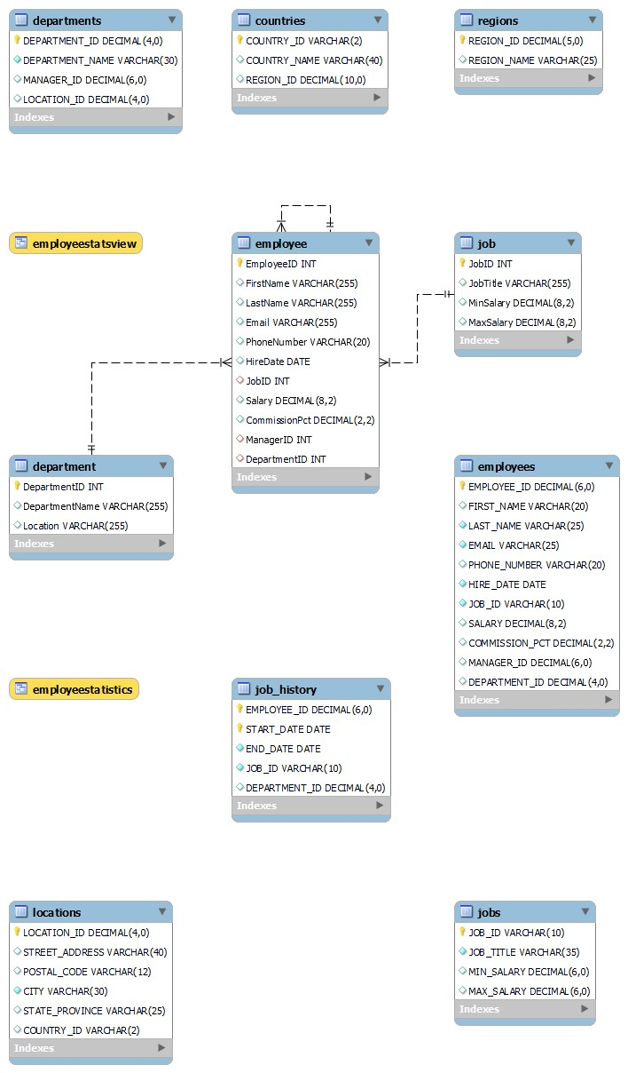

1. **Write a query to find the addresses (location_id, street_address, city, state_province,country_name) of all the departments.**

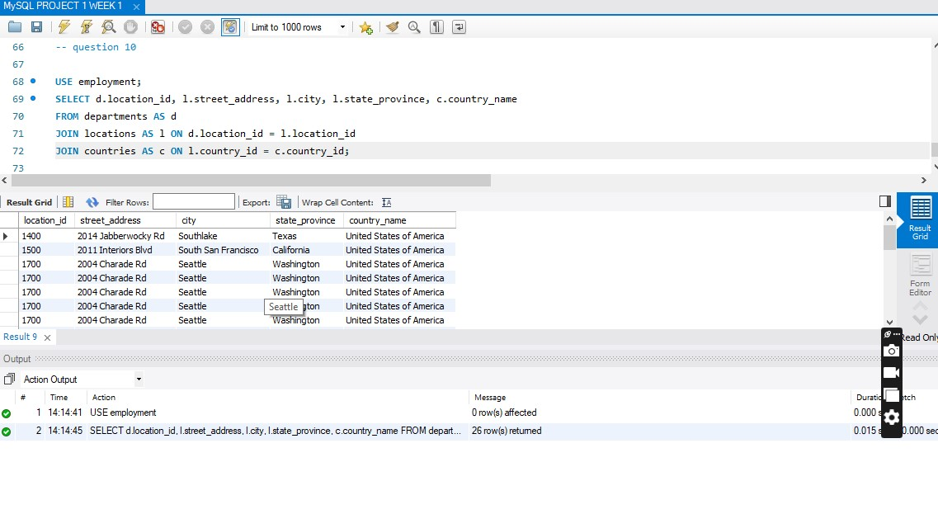

|  |  |  |  |  |
| --- | --- | --- | --- | --- |
| location_id | street_address | city | state_province | country_name |
| 1400 | 2014 Jabberwocky Rd | Southlake | Texas | United States of America |
| 1500 | 2011 Interiors Blvd | South San Francisco | California | United States of America |
| 1700 | 2004 Charade Rd | Seattle | Washington | United States of America |
| 1700 | 2004 Charade Rd | Seattle | Washington | United States of America |
| 1700 | 2004 Charade Rd | Seattle | Washington | United States of America |
| 1700 | 2004 Charade Rd | Seattle | Washington | United States of America |
| 1700 | 2004 Charade Rd | Seattle | Washington | United States of America |
| 1700 | 2004 Charade Rd | Seattle | Washington | United States of America |
| 1700 | 2004 Charade Rd | Seattle | Washington | United States of America |
| 1700 | 2004 Charade Rd | Seattle | Washington | United States of America |
| 1700 | 2004 Charade Rd | Seattle | Washington | United States of America |
| 1700 | 2004 Charade Rd | Seattle | Washington | United States of America |
| 1700 | 2004 Charade Rd | Seattle | Washington | United States of America |
| 1700 | 2004 Charade Rd | Seattle | Washington | United States of America |
| 1700 | 2004 Charade Rd | Seattle | Washington | United States of America |
| 1700 | 2004 Charade Rd | Seattle | Washington | United States of America |
| 1700 | 2004 Charade Rd | Seattle | Washington | United States of America |
| 1700 | 2004 Charade Rd | Seattle | Washington | United States of America |
| 1700 | 2004 Charade Rd | Seattle | Washington | United States of America |
| 1700 | 2004 Charade Rd | Seattle | Washington | United States of America |
| 1700 | 2004 Charade Rd | Seattle | Washington | United States of America |
| 1700 | 2004 Charade Rd | Seattle | Washington | United States of America |
| 1700 | 2004 Charade Rd | Seattle | Washington | United States of America |
| 1800 | 147 Spadina Ave | Toronto | Ontario | Canada |
| 2400 | 8204 Arthur St | London |  | United Kingdom |
| 2700 | Schwanthalerstr. 7031 | Munich | Bavaria | Germany |